**Lab Exercise 13- LCD 16X2 and DHT using Arduino**

Here’s a step-by-step **lab exercise** to interface an **LCD 16x2** and a **DHT11 or DHT22 sensor** with an Arduino to display temperature and humidity data.

**Circuit Diagram:**

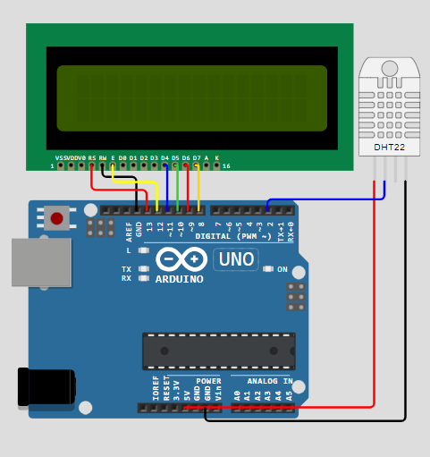

**Arduino Code:**

#include <DHT.h>

#include <LiquidCrystal.h>

#define DHT_PIN 2      // Pin to which DHT22 sensor is connected

#define DHT_TYPE DHT22 // Change to DHT11 if using DHT11 sensor

DHT dht(DHT_PIN, DHT_TYPE);

LiquidCrystal lcd(13,12,11,10,9,8);

void setup() {

  lcd.begin(16, 2);  // Initialize the LCD

  dht.begin();       // Initialize the DHT sensor

  lcd.print("Temp:"); // Display labels on the LCD

  lcd.setCursor(0, 1);

  lcd.print("Humidity:");

}

void loop() {

  // Read temperature and humidity from DHT sensor

  float temperature = dht.readTemperature();

  float humidity = dht.readHumidity();

  // Display the readings on the LCD

  lcd.setCursor(6, 0);

  lcd.print(temperature, 1);

  lcd.print("C");

  lcd.setCursor(9, 1);

  lcd.print(humidity, 1);

  lcd.print("%");

  delay(2000); // Delay between readings (adjust as needed)

}

**Explanation of the Code:**

1. **Libraries**:
   * **LiquidCrystal.h**: Used to interface with the LCD display.
   * **DHT.h**: Library to read data from the DHT11/DHT22 sensor.
2. **Initialization**:
   * The LCD is initialized with the specified pins: (7, 6, 5, 4, 3, 2).
   * The DHT sensor is initialized with its type (DHT11 or DHT22) and the pin it is connected to (pin 8).
3. **In setup()**:
   * The LCD starts, and a message ("Temp & Humidity") is displayed to show the system is initializing.
   * The DHT sensor begins gathering data.
4. **In loop()**:
   * The LCD is cleared at the beginning of each loop to update the screen.
   * The program reads the **temperature** and **humidity** values from the DHT sensor.
   * If the sensor readings fail, an error message is displayed on the LCD.
   * If successful, the current temperature (in Celsius) and humidity (in %) are printed on the LCD.
   * There is a delay of 2 seconds between each update.